Sprint 1 - Endurance Design Document

November 13, 2019

Anthony Cross, Khadar Estime, Robert Hart, Isaiah Bishop

**Table of Contents**

**1.** **EXECUTIVE SUMMARY 3**

1.1 Project Overview 3

1.2 Purpose and Scope of this Specification 3

**2.** **PRODUCT/SERVICE DESCRIPTION 3**

2.1 Product Context 3

2.2 User Characteristics 3

2.3 Assumptions 3

2.4 Constraints 3

2.5 Dependencies 4

**3.** **REQUIREMENTS 4**

3.1 Security 4

*3.2* *Protection* 4

**4.** **REQUIREMENTS CONFIRMATION/STAKEHOLDER SIGN-OFF** 4

**5.** **SYSTEM DESIGN** 4

5.1 Algorithm 4

5.2 System Flow 5

5.3 Software 6

5.4 Hardware 6

5.5 Test Plan 6

5.6 Task List/Gantt Chart 6

5.7 Staffing Plan 6

# Executive Summary

## Project Overview

The overall idea of this project is to design a code with our team for our robot to successfully complete the endurance sprint within our classroom of Howard Hall 208.

## Purpose and Scope of this Specification

The purpose of this project is to complete a flowchart and code for our sphero robot to complete the endurance course around our HH208 classroom.

**In scope**

This document addresses requirements related to sprint 1 of our Robotics Project:

* modification of our flowchart and code are needed to meet the requirements for our endurance course. .

# Product/Service Description

The general factors that could affect the product or its requirements are such as:

Group member avaliablity

Algorithm completion

Test Run completion

## Product Context

This endurance project is within itself it’s own code and project, however it also relates with two other parts of a larger project.

## User Characteristics

General characteristics use.

* Student and teacher use in HH208
* Complete the course and code correctly with robot
* Need to be able to understand sphero app and robot.

## Assumptions

There are many factors and assumptions that could go into the creation of this project, such as:

* Group member availability
* Getting the code correct
* Robot not working correctly

## Constraints

Describe any items that will constrain the design options, including

* floor texture
* correct code
* room space
* criticality of the application
* limits on robot use and sign outs
* Sphero app language compared to python language

## Dependencies

* Our project needs to be worked on weekly in order to complete the endurance course.
* Our flowchart and code needs to be complete in order to complete the endurance course successfully

# Requirements

* Priority 1. Our robot must successfully travel around the periphery of HH208
* Priority 2. A clear path will be provided at a distance of 4 feet from each outside wall.
* Priority 3. Robot should not collide with any objects as it goes around the room.
* Priority 4. Robot should start with a green light and speak ‘ready set go’
* Priority 5. And stop with a red light and speak ‘I’m done and I need water’

## Security

### Protection

We are using Github to secure our codes and project, while only the collaborators have access to the project.

# Requirements Confirmation/Stakeholder sign-off

Include documentation of the approval or confirmation of the requirements here.

|  |  |  |
| --- | --- | --- |
| **Meeting Date** | **Attendees (name and role)** | **Comments** |
| 11/01/19 | Robert Hart, Task Manager and Tester |  |
| 11/13/19 | Anthony Cross, Team Coder  Khadar Estime, Team Tester-01  Isaiah Bishop, Team Tester-02  Robert Hart, Team Task Manager and Tester-03 | confirmed by all team members  Coder, Tester-01, Tester-02, Task Manager/Tester-03 |

# System Design

This section will provide all details concerning the technical design, staffing, coding, and testing the system

## Algorithm

Develop and describe here the algorithm that will be used to provide the required performance of your software

* still

## System Flow

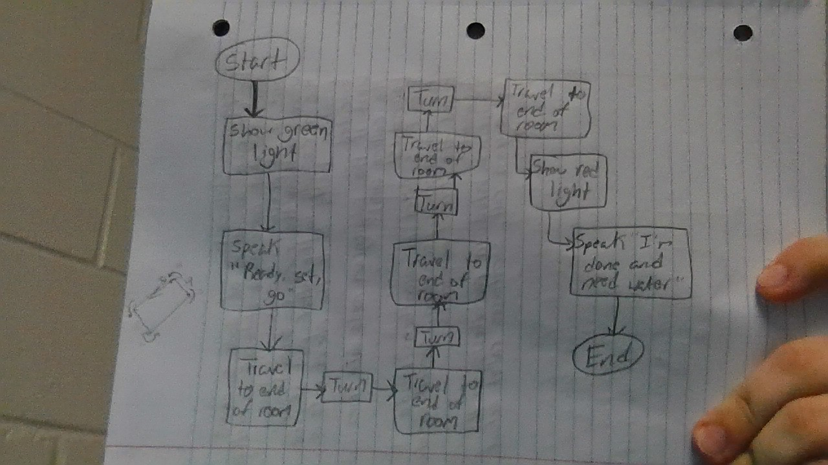

## Software

The sphero app and robot will be used to complete the endurance course

## Hardware

Describe hardware platforms that were used to develop, test and demonstrate this application

## Test Plan

Include a test plan showing all unit tests performed for this application, Include test rational, test date, staff member, pass/fail status

|  |  |  |  |  |  |
| --- | --- | --- | --- | --- | --- |
| **Reason for Test Case** | **Test Date** | **Expected Output** | **Observed Output** | **Staff Name** | **Pass/Fail** |
|  |  |  |  |  |  |
|  |  |  |  |  |  |
|  |  |  |  |  |  |
|  |  |  |  |  |  |
|  |  |  |  |  |  |
|  |  |  |  |  |  |
|  |  |  |  |  |  |
|  |  |  |  |  |  |
|  |  |  |  |  |  |
|  |  |  |  |  |  |
|  |  |  |  |  |  |

65

## Task List/Gantt Chart

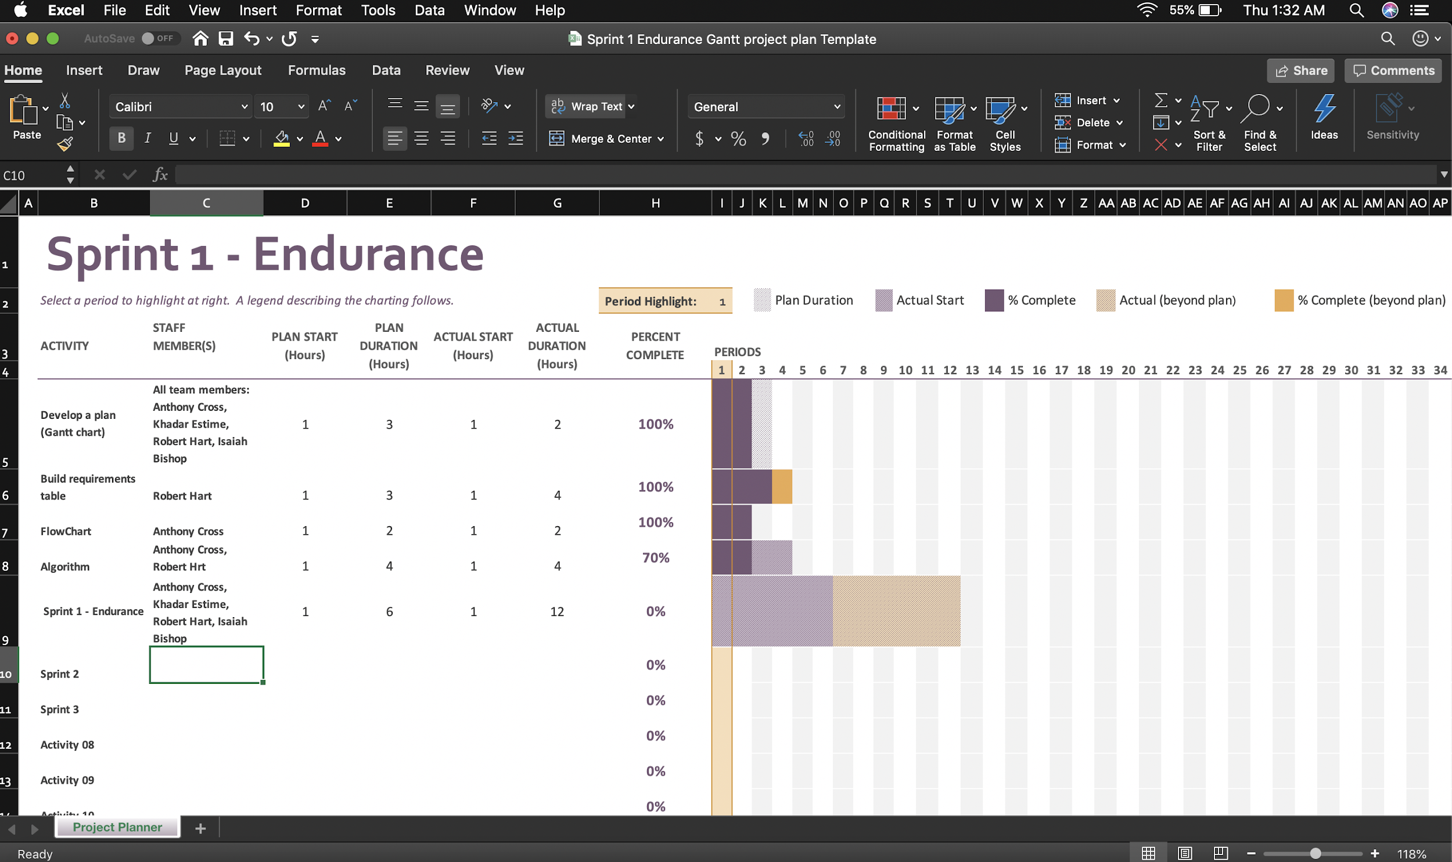

## Staffing Plan

|  |  |
| --- | --- |
| Name | Role |
| Robert Hart | Task Manager and Tester |
| Anthony Cross | Coder |
| Khadar Estime | Tester |
| Isaiah Bishop | Tester |